Figure of the QPG6200L Functional Block Diagram
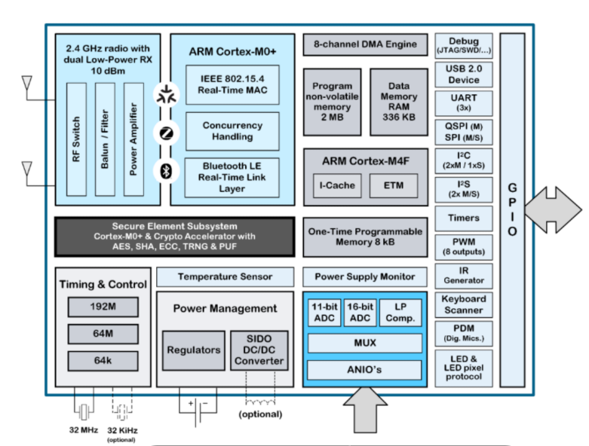
- Temperature Sensor was suggested to be used
- Wanted to record voice input through microphone
- Looks like there’s support for BTE, Thread, Zigbee
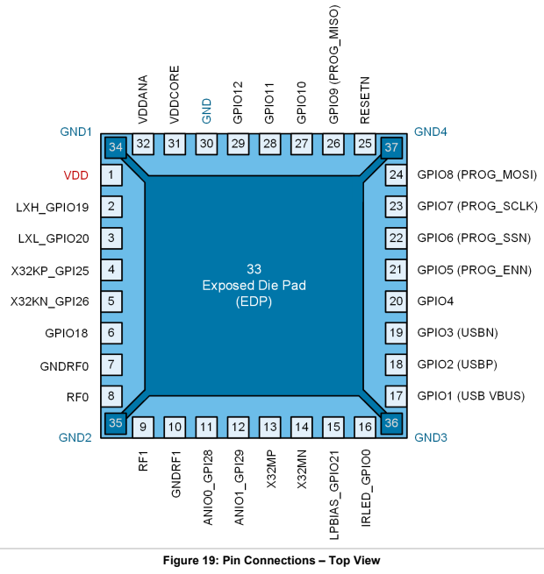
- Security:
  - The QPG6200L is equipped with a low-power Secure Element subsystem providing secure operation functionalities to the application. This subsystem contains a dedicated secure microcontroller, memories and interfaces. It can work independently from the Application Microcontroller, IEEE 802.15.4 MAC and Bluetooth LL.
  - The Secure Element Subsystem supports:
    - Secure Boot (rooted in ROM with Boot Key in OTP), Physical Unclonable Function (PUF)-based Secure (Key) Storage, Secure (Key) Provisioning, Secure Debugging, Secure Device Attestation.
    - Flexible Tampering Detection (Voltage tampering, BBPLL tampering, Boot authentication failure, PK
    - ROM integrity error, SEUC RAM ECC correction or failure, Unauthorized access, Watchdog time-out).
    - Restriction Locks to certain security-sensitive hardware aspects of QPG6200L, e.g., register maps,NVM regions, OTP

- GPIO Pins
- GPIO Pin Assignment Tables for various functions
- Wake up: an event that can be triggered on a rising edge, on a falling edge, or on both edges seen on the pin.
- High Drive Sink: can be enabled for driving a high-power circuit or anything requiring more power
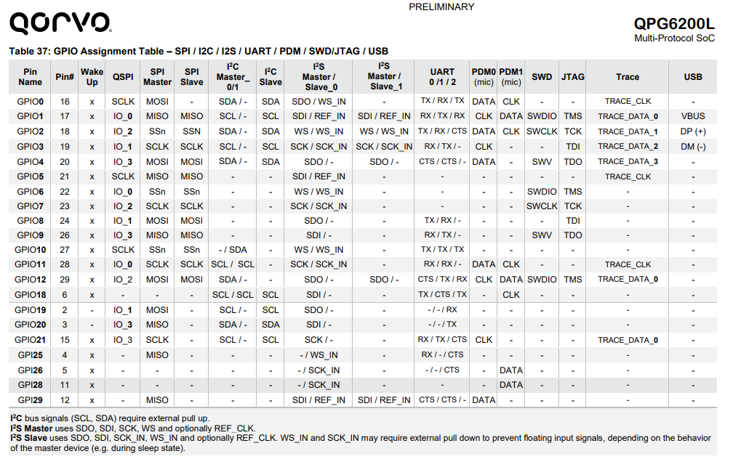
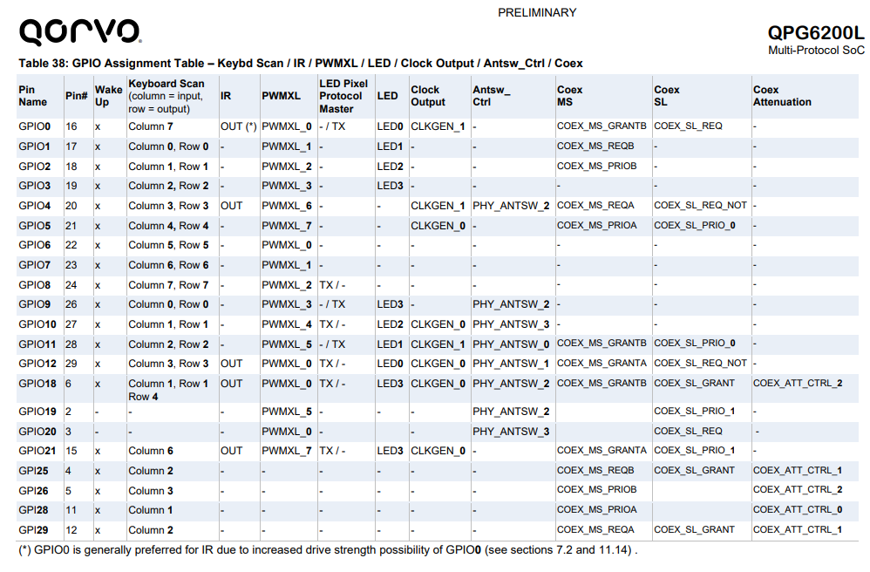
- ANIO / ADC
Components:
- High-resolution 16-bit ADC
- General Purpose 11-bit ADC
- Low-power Comparator.
- Battery / Temperature Monitor: The ADC module can be configured by software to monitor the power supply level internally; no external components are required. The power supply level and temperature are measured separate from the ANIO pins
- Keyboard Scanner
- The QPG6200L has an integrated 8x8 Keyboard Scanner with ultra-low power wake-up on key press, keyboard scan and de-bounce. The keyboard scan operation is triggered by a change on the IO (key press), as well as by a timed event (for de-bouncing). The keys are organized in a matrix. The mapping of the physical keys (row/column) to the application or profile-defined keys is software configurable. The maximum number of keyboard columns and rows depends on the number of other GPIO-devices enabled; see Table 38.
- Column = Input Row = Output
- InfraRed (IR) generator.
- The IR carrier and modulation parameters and codes are defined by the application software. The IR generator supports a wide range of common IR protocols.
- The IR generator supports multiple modulation modes:
  - Pattern based: input is a pattern of 0’s and 1’s in RAM
  - Time based: input is a sequence of ON and OFF times
  - Event based: modulation is controlled by scheduled actions.
- LED Generators (4 that with configurable function and events)
- It supports:
- 8-bit Pulse-Width Modulation (PWM)
- Fade-in/Fade-out
- Duty cycling to adjust brightness and save power
- LED Pixel Protocol Master (RTZ)
- two LED Pixel Protocol Masters which support many commercially available LED pixel driver IC’s using the RTZ (Return To Zero) protocol
- This will enable sending frames for all pixels, without microcontroller intervention
- Supports Sequential (Neopixel) and Random (Christmas tree) addressing
- PDM Microphone Interface
- The QPG6200L contains two Pulse-Density Modulation (PDM) MEMS Microphone Interfaces. It provides conversion from a Pulse Density Modulated signal (PDM), which is typically used for low-cost digital microphones, to a 16-bit Pulse Code Modulated signal (PCM). The PCM signal can then be used for further processing and compression of the audio using the embedded Audio Signal Processors.
- The PDM interfaces supports:
  - A Clock and Data pin for interfacing with a PDM MEMS microphone.
  - Optionally Capturing Data on the Rising and Falling Edge of the Clock for Stereo operations.
  - Configurable frequency of Clock signal: Default = 2 MHz and Digital frequency synthesizer for generating frequencies up to 3072 kHz.
- PWM Engine
- The PWM peripheral enables the generation of 16-bit pulse width modulated signals on an assigned GPIO.
- Generic Timers
- contains a number of generic timers; 6x 32-bits or 12x 16-bits (software selectable), allowing time intervals to be defined by the user
- Each timer has 4 capture/compare channels allowing generating interrupts when the count value matches the compare value, or to capture the count value on a configurable event (e.g., an external pin event).

